INFORMATION FOR PATIENTS

Manor Apartments, 289 Queen Street, Brisbane, QLD 4000 Ph: 3221 3366 (All hours), Fax: 3221 3082
Website: www.BrisbaneCityDoctors.com.au Email: reception@brisbanecitydoctors.com.au Nurse@brisbanecitydoctors.com.au

ABOUT US
ber 2020

Welcome to BRISBANE CITY DOCTORS

We have a quality accredited comprehensive modern traditional general practice, offering a wide range of services to all age groups for their long-term care.

The co-located doctors are SPECIALISED general practitioners, that is, they have two medical degrees. Their primary medical degree (MBBS) and their General Practice specialist degree (FRACGP). This correlates to a minimum of ten years medical training. Doctors also have additional training in various special interest areas to assist our patients with specific health care needs.

All the doctors participate in regular continuing education to keep up to date with the latest medical information and treatments. The latest in medical equipment and highly trained nursing staff are available to assist in your care.

Visit our website to find out more about us. http://www.BrisbaneCityDoctors.com.au.
We take the quality of care we offer our patients very seriously, so all our systems and processes are designed to ensure you receive the best quality care available.

PLEASE BOOK ALL ONLINE APPTS ONLINE TO TAKE LOAD OFF FRONT DESK

WE HAVE A NEW WALK IN CLINIC AT QUEEN ST FRONTAGE. ALSO WALK IN FLU VAX THERE

AGPAL ACCREDITED PRACTICE

Manager Contact: manager@BrisbaneCityDoctors.com.au Admin Practice Coordinator: Annie (admin@brisbanecitydoctors.com.au) Admin: Hanna, Angela, Maxine Pia (reception@brisbanecitydoctors.com.au All Medicals and Physicals contact is Hanna (admin@allmedicals.com.au)
Nurses: Fallon, Jodie, Raquel, Amy , (nurse@brisbanecitydoctors.com.au)

Medical Director: Dr Margaret McAdam MBBS FRACGP MBA GAICD Grad Cert Appl Clin Genetics

SURGERY HOURS
Monday – Friday 7 am – 6 pm-
(NO BULKBILLING/ REDUCED FEES BEFORE 8AM AND AFTER 4PM or SATS FULL PRIVATE BILLING FOR ALL )
(last appointment 5:30pm) Saturday9 am – 1 pm (last appointment 12.30)
Sunday/Public Holidays CLOSED
MASKS REQUIRED UNLESS YOU HAVE A LEGAL EXEMPTION. ALL MASKLESS PERSONS INCLUDING CHILDREN HAVE TO BE TRIAGED VIA A TELEHEALTH APPT FIRST. WITH NO MASK YOU POSE A RISK TO OTHERS SO WE NEED TO MANAGE THAT RISK FOR THE SAFETY OF OTHERS. APPTS CAN BE OFFERED AT CERTAIN TIMES OF DAY . SITTING IN OUR WAITING ROOM IS NOT PERMITTED AND OTHER ARRANGMENTS WILL BE MADE

THE DOCTORS
or during after hours. All

Dr Stacey Deshong | MBBS, FRACGP ABN: 56156418145
Usual Consulting Days | Monday - Tues
Billing Policy | Telehealth  Telehealth phone/video appointments are charged at  10min Telehealth: $72-$86 (rebate $39.10) (depends on time , complexity and number of issues discussed)  20min Telehealth: $105 -$149 (rebate $75.75).  Note: Medicare rebate for Telehealth is only available if you have been seen by one of the doctors within the past 12 months.  Onsite Appointments  Standard Consultation (10mins): $68 to $86 (rebate $39.10) Long Consultation (20mins): $149 (rebate $75.75)  After Hours (Before 8am):  10mins $97 (rebate $50.80) 20mins $158 (rebate $85.30)  Saturday  10mins $97 (rebate($39.10) 20mins $158 (rebate $75.75)  Bulk Billing  Bulk billing on site appointments for standard consultations may be available for children under 16 years, at Drs discretion  HCC holders, pensioners and students have a $15 gap above rebate  Note: There is strictly no bulk billing on Saturdays - full private billing  bulk billing is at doctor’s discretion.
Special Interests | General Consultations, Mental Health , Company Medicals, Skin checks, ear microsuction, implanon insertion/ removal. Mirena removal

Dr Pav Chopra | MBBS, DRCOG, MRCGP (UK), FRACGP ABN: 59070232123
Usual Consulting Days | Monday - Friday 8 AM - 4 PM  PAV WORKS IN OUR WALK IN CLINIC AT QUEEN ST FRONTAGE
Billing Policy | Telehealth  Telehealth phone/video appointments are charged at  10min Telehealth: $72-$86 (rebate $39.10) (depends on time , complexity and number of issues discussed)  20min Telehealth: $105 -$149 (rebate $75.75).  Note: Medicare rebate for Telehealth is only available if you have been seen by one of our doctors within the past 12 months.  Onsite Appointments  Standard Consultation (10mins): $68 to $86 (rebate $39.10) Long Consultation (20mins): $149 (rebate $75.75)  After Hours (Before 8am):  10mins $97 (rebate $50.80) 20mins $158 (rebate $85.30)  Saturday  10mins $97 (rebate($39.10) 20mins $158 (rebate $75.75)  Bulk Billing  Bulk billing on site appointments for standard consultations are available for, children under 16 years at Drs discretion,  HCC holders, pensioners and students have a $15 gap above rebate

 | Note: There is strictly no bulk billing on Saturdays or during after hours. All bulk billing is at doctor’s discretion.
Special Interests | General Consultations, Men's Health and Travel Advice, Company Medicals
Dr Michael Edwards | MBBS, FRACGP, BPhty ABN: 66956859062
Usual Consulting Days | Monday, Tuesday, Thursday and Friday
Billing Policy | Telehealth  Telehealth phone/video appointments are charged at  10min Telehealth: $72-$86 (rebate $39.10) (depends on time , complexity and number of issues discussed)  20min Telehealth: $105 -$149 (rebate $75.75).  Note: Medicare rebate for Telehealth is only available if you have been seen by one of our doctors within the past 12 months.  Onsite Appointments  Standard Consultation (10mins): $68 to $86 (rebate $39.10) Long Consultation (20mins): $149 (rebate $75.75)  After Hours (Before 8am):  10mins $97 (rebate $50.80) 20mins $158 (rebate $85.30)  Saturday  10mins $97 (rebate($39.10) 20mins $158 (rebate $75.75)  Bulk Billing  Bulk billing on site appointments for standard consultations are available for, children under 16 years, at Drs discretion  HCC holders, pensioners and students have a $15 gap above rebate  Note: There is strictly no bulk billing on Saturdays or during after hours. All bulk billing is at doctors discretion.
Special Interests | Men's health, General consultations, Sports / musculoskeletal medicine, Dermatology issues, Sexual health, Erectile dysfunction
Dr Christopher Watson | MBBS, FRACGP ABN: 98974185796
Usual Consulting Days | Monday, Tuesday Thursday and Friday
Billing Policy | Telehealth  Telehealth phone/video appointments are charged at  10min Telehealth: $72-$86 (rebate $39.10) (depends on time , complexity and number of issues discussed)  20min Telehealth: $105 -$149 (rebate $75.75).  Note: Medicare rebate for Telehealth is only available if you have been seen by one of our doctors within the past 12 months.  Onsite Appointments  Standard Consultation (10mins): $68 to $86 (rebate $39.10) Long Consultation (20mins): $149 (rebate $75.75)  After Hours (Before 8am):  10mins $97 (rebate $50.80) 20mins $158 (rebate $85.30)  Saturday  10mins $97 (rebate($39.10) 20mins $158 (rebate $75.75)  Bulk Billing  Bulk billing on site appointments for standard consultations are available for, children under 16 years, at Drs discretion

HCC holders , pensioners and students have a $15 gap above rebate

Note: There is strictly no bulk billing on Saturdays or during after hours. All bulk billing is at doctors discretion.
Special Interests | Mole Scanning, Skin/Musculoskeletal Problems, Men's Health, Weight Management, skin surgery, skin cancer and melanoma surgery, General consultations
Dr David White | BSc, MBBS, MPH, FRACGP ABN: 88494451258
Usual Consulting Days | Monday, Tuesday, Thursday and Friday
Billing Policy | Telehealth  Telehealth phone/video appointments are charged at  10min Telehealth: $72-$86 (rebate $39.10) (depends on time , complexity and number of issues discussed)  20min Telehealth: $105 -$149 (rebate $75.75).  Note: Medicare rebate for Telehealth is only available if you have been seen by one of our doctors within the past 12 months.  Onsite Appointments  Standard Consultation (10mins): $68 to $86 (rebate $39.10) Long Consultation (20mins): $149 (rebate $75.75)  After Hours (Before 8am):  10mins $97 (rebate $50.80) 20mins $158 (rebate $85.30)  Saturday  10mins $97 (rebate($39.10) 20mins $158 (rebate $75.75)  Bulk Billing  Bulk billing on site appointments for standard consultations are available for,  children under 16 years, at Drs discretion  HCC holders, pensioners and students have a $15 gap above rebate  Note: There is strictly no bulk billing on Saturdays or during after hours.  Full private billing on Sats
Special Interests | Mental health care ,General Consultations, Men's Health, Musculoskeletal Medicine, Preventative medicine, sexual health (excluding PEP/PreP), childrens  health, iron infusions, ear microsuction, dermatology issues, family planning/preconception advice

Dr Trang Huynh | MBBS, FRACGP ABN: 91133695480
Usual Consulting Days | Monday, Alternating Tuesday/Wednesday, Thursday
Billing Policy | Telehealth  Telehealth phone/video appointments are charged at  10min Telehealth: $72-$86 (rebate $39.10) (depends on time , complexity and number of issues discussed)  20min Telehealth: $105 -$149 (rebate $75.75).  Note: Medicare rebate for Telehealth is only available if you have been seen by one of our doctors within the past 12 months.  Onsite Appointments  Standard Consultation (10mins): $86 (rebate $39.10) Long Consultation (20mins): $149 (rebate $75.75)  After Hours (Before 8am): 10mins $97 (rebate $50.80) 20mins $158 (rebate $85.30)

Saturday
10mins $97 (rebate($39.10) 20mins $158 (rebate $75.75)
Bulk Billing
Bulk billing on site appointments for standard consultations are available for, children under 16 years, at Drs discretion

HCC holders, pensioners and adult students have a $15 gap above rebate

Note: There is strictly no bulk billing on Saturdays or during after hours. bulk billing is at doctors discretion.
Special Interests | General Consultations, Dive Medicals, Woman's Health, Mirena removals, Implanon insertion/removal, Simple Excisions/ Biopsy of skin lesions and cancers.
Full private billing

Dr Angela Sprott | MBBS, FRACGP ABN: 44601380159
Usual Consulting Days | Monday, Tuesday, Wednesday
Billing Policy | Telehealth  Telehealth phone/video appointments are charged at  10min Telehealth: $72-$86 (rebate $39.10) (depends on time , complexity and number of issues discussed)  20min Telehealth: $105 -$149 (rebate $75.75).  Note: Medicare rebate for Telehealth is only available if you have been seen by one of our doctors within the past 12 months.  Onsite Appointments  Standard Consultation (10mins): $68 to $86 (rebate $39.10) Long Consultation (20mins): $149 (rebate $75.75)  After Hours (Before 8am):  10mins $97 (rebate $50.80) 20mins $158 (rebate $85.30)  Saturday  10mins $97 (rebate($39.10) 20mins $158 (rebate $75.75)  Bulk Billing  Bulk billing on site appointments for standard consultations are available for, children under 16 years, at Drs discretion  HCC holders, pensioners and students have a $15 gap above rebate  Note: There is strictly no bulk billing on Saturdays or during after hours.  Private billing on Saturdays and after hours.
Special Interests | General Consultation and Women's Health
Dr Flora Cheong | MBBS BBiomed sc(Hons) FRACGP FRACGPMBBS ABN: 98344141595
Usual Consulting Days | Tuesday - Wed- Thurs
Billing Policy | Telehealth  Telehealth phone/video appointments are charged at  10min Telehealth: $86 (rebate $39.10) (depends on time , complexity and number of issues discussed)  20min Telehealth: $149 (rebate $75.75).  Note: Medicare rebate for Telehealth is only available if you have been seen by one of our doctors within the past 12 months.  Onsite Appointments  Standard Consultation (10mins): $86 (rebate $39.10)

Long Consultation (20mins): $149 (rebate $75.75)
After Hours (Before 8am): 10mins $97 (rebate $50.80) 20mins $158 (rebate $85.30)

Saturday
10mins $97 (rebate($39.10) 20mins $158 (rebate $75.75)
Bulk Billing- Does not Bulkbill
Special Interests | Skin checks, General practice, Women's health, Ear Microsuction, Implanon removal & insertion, General consultations

Dr Emma Bourke | MBBS, FRACGP, DipPaeds ABN: 60154653529
Usual Consulting Days | Moved to Northern NSW
Billing Policy | Moved to NSW
Dr Kalyani Komzak | MBBS, FRACGP ABN: 81906128488
Usual Consulting Days | Monday Wednesday, Thursday ,Friday - 8 AM -4 PM
Billing Policy | Telehealth  Telehealth phone/video appointments are charged at  10min Telehealth: $72-$86 (rebate $39.10) (depends on time , complexity and number of issues discussed)  20min Telehealth: $105 -$149 (rebate $75.75).  Note: Medicare rebate for Telehealth is only available if you have been seen by one of our doctors within the past 12 months.  Onsite Appointments  Standard Consultation (10mins): $68 to $86 (rebate $39.10) Long Consultation (20mins): $149 (rebate $75.75)  After Hours (Before 8am):  10mins $97 (rebate $50.80) 20mins $158 (rebate $85.30)  Saturday  10mins $97 (rebate($39.10) 20mins $158 (rebate $75.75)  Bulk Billing  Bulk billing on site appointments for standard consultations are available for, children under 16 years,  HCC holders, pensioners and students have a $15 gap above rebate  Note: There is strictly no bulk billing on Saturdays or during after hours. All bulk billing is at doctors discretion.
Special Interests | Implanon removal & insertions, Mirena removal, Ear microsuction, Skin issues, skin cancer checks,, Medicinal cannabis, Womens Health, General Practice
Dr Jan Casey | MBBS, RACGP,BA SocSc (Dist), Psych ABN: 49860994977
Usual Consulting Days | On Sabbatical
Billing Policy | Telehealth  Telehealth phone/video appointments are charged at  10min Telehealth: $72-$86 (rebate $39.10) (depends on time , complexity and number of issues discussed)  20min Telehealth: $105 -$149 (rebate $75.75).

Note: Medicare rebate for Telehealth is only available if you have been seen by one of our doctors within the past 12 months.
Onsite Appointments
Standard Consultation (10mins): $68 to $86 (rebate $39.10) Long Consultation (20mins): $149 (rebate $75.75)
After Hours (Before 8am): 10mins $97 (rebate $50.80) 20mins $158 (rebate $85.30)

Saturday
10mins $97 (rebate($39.10) 20mins $158 (rebate $75.75)
Does not bulkbill
Special Interests | General Practice, Women's Health, Mental Health and Travel advice
Dr Loretta Deuble | MBBS (HON), Bmedsci, FRACGP ABN: 26847302651
Usual Consulting Days | Monday – Friday
Billing Policy | Dr Loretta is private bill only Telehealth  Telehealth phone/video appointments are charged at  10min Telehealth: $72-$86 (rebate $39.10) (depends on time , complexity and number of issues discussed)  20min Telehealth: $105 -$149 (rebate $75.75).  Note: Medicare rebate for Telehealth is only available if you have been seen by one of our doctors within the past 12 months.  Onsite Appointments  Standard Consultation (10mins): $68 to $86 (rebate $39.10) Long Consultation (20mins): $149 (rebate $75.75)  After Hours (Before 8am): 10mins $97 (rebate $50.80) 20mins $158 (rebate $85.30)  Saturday  10mins $97 (rebate($39.10) 20mins $158 (rebate $75.75)
Special Interests | General Practice and Women's Health
Dr Leanne Barron | MBBS, FRACGP
Usual Consulting Days | Moving to Banyans in Sept (private drug , alcohol and eating disorders centre in Bowen Hills). Please contact them for any appts and transfer of care

Dr Jacqueline Kelly | MBBS, FRACGP ABN: 18153972331
Usual Consulting Days | Tuesday
Billing Policy | Telehealth  Telehealth phone/video appointments are charged at  10min Telehealth: $72-$86 (rebate $39.10) (depends on time , complexity and number of issues discussed)  20min Telehealth: $105 -$149 (rebate $75.75).  Note: Medicare rebate for Telehealth is only available if you have been seen

by one of our doctors within the past 12 months.

Onsite Appointments
Standard Consultation (10mins): $68 to $86 (rebate $39.10) Long Consultation (20mins): $149 (rebate $75.75)

After Hours (Before 8am):
10mins $97 (rebate $50.80) 20mins $158 (rebate $85.30)

Saturday
10mins $97 (rebate($39.10) 20mins $158 (rebate $75.75)

Bulk Billing
Bulk billing on site appointments for standard consultations are available for,
children under 16 years, at Drs discretion

HCC holders , pensioners and students have a $15 gap above rebate

Note: There is strictly no bulk billing on Saturdays or during after hours. All bulk billing is at doctors discretion.
Special Interests | General Practice, Skin Cancer Checks/ Excisions, Women's Health, Travel Medicine, Musculoskeletal and Sports Medicine, Mirena consults and removal

BILLING
We are a mixed billing practice. All private consultations are to be paid in full on the day. Medicare returns their portion same day if you have your bank account registered with them and advise staff.

Children under 16 are bulkbilled at Drs discretion
HCC holders, adult students and pensioners have a $15 gap on top of rebate. (Full payment on the day)

Full Skin checks (20mins) and excisions are not bulkbilled. Long women’s health appts (30 MINS) are not bulkbilled
Excisions, Full molescans, visits (20 mins), and home visits are private billed.
- All WorkCover appointments must be paid on the day and patients seek reimbursement. We do not bill direct to WorkCover

Some DRs so not bulkbill at all- Consult our website for fees details for the different doctors.

APPOINTMENT LENGTH AND FEES
It is important that you request the time you need to ensure the Dr can do their best for you. Too little time places them under pressure.
Default is 10 mins unless you request longer
- 10-minute appointment
- 20-minute appointment
- Longer than 20-minute appointments are available on request at time of booking, but they are not bulkbilled for anyone. Please ask for the length of appointment you want when you book. If you are unsure, ask our receptionists.
- Medicals must be booked with advance notice and you are required to be here 30 minutes before the doctor needs to see you. If you arrive late the medical may need to be cancelled.
- There is a cancellation fee if you do not arrive for the appt or are so late it has to be cancelled.
- Excisions must be seen by the Dr in a first appt to assess time needed and any other preparation needed. and the excision is booked on 2nd appt

PRIVATE PATIENT FEES
- Standard $86
- Longer $149
- Longer+ $ $198-$220
If you do not specify a length of appointment at time of booking it will be assumed to be a standard 10 minute appointment, and unless urgent, you may be asked to return again if there is not enough time to properly

manage your health complaint in one appointment. People who don’t book enough time compromise their medical care by asking Drs to do the impossible. Good medicine takes time! Be sure to tell the Dr of your ethnicity as it holds important health information for them. Always tell the DR of your emergency contact
If you are late for your appointment, you may have to rebook your appointment at another time. Otherwise you will delay every appointment after you which is unfair to our other patients who are busy working people on tight time schedules.
If you wish to make a 10 min appointment there is no time in these brief appointments for more than one simple obvious diagnosis problem to be discussed and you may be required to make another appointment at a later date if you have not booked enough time to ensure proper care occurs.
Two 10-minute problems = a 20-minute appt.
An appt where the diagnosis is not obvious and involves pain or tiredness or mood changes or womens issues - will be min 20 min

Typical 10-minute appointments ($86.00)
Urine infection Rash
Skin infections Sports injury
Vaginal discharge Pregnancy tests
Ear infection Morning after pill
Sore eye or ear Blood pressure check
STD check Ear infection
Minor injuries Infections Breast check (no pap)
Pap alone (suits young healthy women under 35) Upper respiratory tract infection
Simple results discussion

Typical 20-minute appointments ($149.00) +
Menopause counselling
Asthma review with breathing tests New patient starting on pill
Cervical screening test and breast check Travel advice
Counselling
Mothers 6 week check up after baby born If combined with baby 6 week check book 2 x 20min appts Excisions - std 10 min appt first to assess
A couple of minor 10 min problems Depression/mood problems
Child vaccination and growth checks Mental Health appointments Mental Health Plans $180
Care plan appointments mostly bulkbilled. But check with your DR
Investigations of any of the following: Headaches, tiredness, abdominal pain, chest pain,
dizziness, back pain, vaginal bleeding, lower abdominal pain,
Full women’s health check (recommended for anyone over 35 years) with pap, breasts, BP and discussion NOTE: ALL LOWER ABDOMINAL PAIN IN FEMALES / VAGINAL BLEEDING APPTS REQUIRE A CERVICAL SCREENING TEST AND 20 MIN APPTS

Typical 30 mins appointments ($198-$220.00) +(may vary between Drs)
Complex mental health plans Complex problems to discuss Counselling
Men’s or women’s health check up with any extra issues or items to discuss

EXTENDED APPOINTMENTS
We offer longer appointments on request. These are not bulk billed appointments and are billed at 30 mins $198-$220, 40 mins $295.(rebate $78.05). Sad isn’t it that medicare does not support quality care with such a low rebate for more time with the doctor.

ADMIN AND FORM FILLING FEE
Any certificate or form that is filled in outside of a consultation attracts a fee. Book a brief telehealth admin / question appt online
If you request results, immunisation records, copies lost referrals , there is a retrieval fee of $10-$25 or you can book an admin Telehealth appt to allot time for the Dr to do them(Drs mostly BB these)

ACCIDENTS AND EMERGENCY
Always telephone the surgery first and you will be advised of the appropriate action. However, if you have chest pain or symptoms of stroke eg: weakness and numbness or speech problems, or severe allergic reaction with itchy rash, swelling, breathing problems, or very sick child, call 000 immediately.
PLEASE ALWAYS ADVISE RECEPTIONIST IF YOU THINK YOUR PROBLEM COULD BE AN URGENT ONE.
We have translating services available if needed

MEDICAL CERTIFICATES
These will not be issued for non-medical reasons apart from bereavement or family support. The patient must be seen or attend a telehealth appointment at the time of the illness for a certificate to be written. They cannot be backdated as it is illegal.

*NEW* HOT DOC and AUTOMED ONLINE
BOOKINGS encourage for all appts
Log on to www.brisbanecitydoctors.com.au to book online.
Waiting Time Management. Hot Docs will also, if you have downloaded their app and turned on notifications, notify you on arrival of your likely time to be next patient in. If you are really keen, you can phone the surgery 30mins ahead, ask staff to register you as arrived, and you will be notified at work when you are the next patient.
So as long as you can get here within a few minutes, you can walk in into your appointment with minimal waiting time, allowing you to continue to work right up to your appointment time. This is very handy for busy working people.
You can check yourself in on the Hotdoc app as well on arrival If you have been waiting more than 20 mins please contact staff though Telehealth appts do have a more flexible start time about contact reception if no call by 30mins in case your number is incorrect or phone is accidentally flat or off or going to message bank(this happens a lot!)

TO REQUEST A PRESCRIPTION
Modern medications are potent and can lead to harmful side effects if taken inappropriately. It s important you be regularly reviewed while on medication to check for any possible side effects, to receive updates on whether it is still the best one for your condition and to remind you about interactions or new side effects warning with any other medication you may be taking.
This practice does not prescribe narcotics or drugs of addiction.
Visit www.brisbanecitydoctors.com.au and book a telehealth appt. Drs bill between (may be BB OR REDUCED FEE for eligible patients to $72-$86 if other issues addressed)

Please read our Prescription guidelines below before requesting repeat prescriptions.
Important Note: Doctors can decline your request for online prescription if you have not been seen for 6 months or more or we have never prescribed the medication for you in the past. In these cases, repeat prescriptions will not be issued without a visit to the doctor. For a telehealth appt you must have been seen face to face in the last 12 mths or there is no medicare rebate
Scripts for antidepressants, opiates, sleeping tablets with addictive potential will not be given without a face to face appointment with your usual Dr. Pill scripts when pap is overdue will only have a couple of months script provided and will require a visit after that

REPEAT PRESCRIPTIONS

TO REQUEST REFERRALS & PRESCRIPTIONS
Make a telehealth appt online. These may be billed at $53-$86 if no other issues discussed at the appt. Can increase to $86 if other items discussed. Rebate$39.10
However Dr McAdam will do a bulkbill repeat script for known patients for known problems as long as not painkillers, sleepers, or mental health medications. Any telehealth request online will be only accepted if you have been seen in the previous 12 months and there is no further preventive care due.

Note: Please refer to our referral guidelines below before requesting referrals online. These are managed by a telehealth appt now

REFERRALS
Medicare requires the GP to assess their patients before referring any patient to a specialist. This referral process allows for the efficient and proper use of consultant resources and ensures fair and timely access to specialist services by patients who need them. Referrals are valid for 12 months. This is because it is intended that patients visit their GP at least annually for reassessment and to ascertain if the referral is still indicated and it has your latest up to date information.
By law, referrals CANNOT be backdated. Please do not ask doctors to do this, as they will have to politely refuse. It is the specialist's receptionists and your responsibility to ensure you have a current referral before your visit. Book
Due to time constraints calls from specialists on the day to do a referral cannot be accommodated. If you see a specialist without a referral from your doctor, you will have to bear the cost of the consultation as no Medicare rebate will be payable. Provision of a referral usually requires a visit to the doctor but a telehealth appt will be ok to book for these to update relevant information
Any request online will be only accepted if you have been seen in the previous 6 months and there is no further preventive care due.

PARKING
The closest parking is available at either Post Office Square, Wintergarden, Central Plaza 1 or Macarthur Central. If you go to Secure a park, there is discounted parking you can buy on “secure a park” before you come in.

FOREIGN LANGUAGES
Interpreter services are available on request. It is essential that those patients with limited English skills have an interpreter present and book a long appointment. Another friend or family member may act as the interpreter if their English language skills are good and you consent to them being present throughout and can talk freely with them there.

X-RAY and ULTRASOUND FILMS
Please collect your films before you leave your consultation as we cannot store them for you. All X- rays left on the premises after 3 months will be destroyed, so please take your x-rays with you. Never leave mammograms here - always take them with you. Never assume a Dr has seen your result. Sometimes radiologists fail to send us these and you may have the only copy in your x-ray packet. Always return for x-ray results. If you require hard copy or copies for yourself or specialists – ask the radiology place to provide direct to the specialists

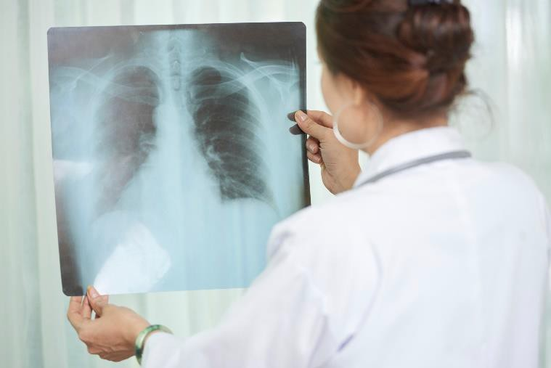

CONTINUITY OF CARE
It is in your best interest to have a regular doctor. It is very important to see and speak to the same doctor to

follow through on a problem. Doctors prefer not to take other doctors calls or appointments for results as they are not familiar with your history and cannot advise on what follow up you need and results cannot be interpreted without knowledge of your full history. Therefore, obtaining results will require a visit to your doctor unless they have said otherwise. Valuable information may be lost if you change doctors frequently.
So wherever possible, make all of your follow up appointments with the same doctor who ordered your tests and has been following your condition. Failing that, be seen at the same practice where all your notes are present to the treating doctor.
If you also see another Dr elsewhere, ask for results and information to also be sent here, so we keep a full history on you. Fragmented care can lead to lesser quality care.

COMPLAINTS AND SUGGESTIONS
We constantly strive to give you the best possible care and attention. We value your feedback and have an app that will send you a survey a few hours post visit so you can give direct feedback. You may also request to speak to the practice manager or give feedback through our website.
Alternatively, you can put your concerns in writing to the Practice Manager at manager@brisbanecitydoctors.com.au. It will be fully investigated, and appropriate action taken, and you will be kept informed.
Or alternatively you can lodge your complaint to the Office of Health Ombudsman.
If you are not satisfied with our response you are entitled to contact the Office of the Australian Information Commissioner, by phoning 1300 363 992 or writing to the Director of Complaints, Office of the Australian Information Commissioner, GPO Box 5218, Sydney NSW 1042.

STAFF POLICY
We value our staff who have a very difficult task juggling the needs of doctors, patients and ringing phones. Your patience is appreciated. As employers we are obligated to provide a safe workplace for our staff. Patients who verbally abuse or threaten our staff will be asked to leave the practice and seek their care elsewhere. Our reception staff are not clinically trained and as such are not permitted to give results. These enquires go to your doctor by emailing reception@brisbanecitydoctors.com.au or
nurse@brisbanecitydoctors.com.au. This is not suitable for urgent enquires. Please phone for those.
PLEASE DO NOT RING OR EMAIL ASKING IF YOUR RESULTS ARE BACK. THIS CREATES ENORMOUS LOAD ON STAFF. PLEASE MAKE AN APPT FOR FOLLOW UP OR WAIT FOR DRS SMS OR EMAIL MESSAGE. ONLY CONTACT AFTER REASONABLE TIME HAS PAST AND THE DR HAS NOT CONTACTED YOU (unless an urgent result)
PLEASE ENSURE YOU HAVE GIVEN PERMISSION TO SMS YOU AND/OR EMAIL YOU AND YOUR PHONE NUMBER IS CURRENT AND YOUR EMAIL IS NOT A WORK or JOINT FAMILY ONE. PLEASE ADVISE IF WE CANT CONTACT YOU ABOUT RESULTS AND APPTS VIA SMS OR EMAIL.

TELEPHONE CALLS
As you are aware, interruptions during the course of a consultation can be very distracting for both doctor and patient. Most queries are best dealt with by on- site consultation, or a telephone query with you via a telehealth appointment.
If you want to send a message to the Dr please email this to reception@brisbanecitydoctors.com.au rather than call as the phones are very busy. It will be forwarded to the Dr to respond to. But if the item is better dealt with by consultation please make one .
Please indicate if you call is urgent If you feel you have a serious problem that requires immediate attention and indicate this to staff. One of the staff will speak with the nurse/doctor or the ambulance service if necessary.
Results messages will generally come via Sms message to you with a safe link to click or email if we cannot contact you via Sms
Doctors don’t ask patients to return if everything is normal and there is no further follow up required. So, if you have been asked to return for results it’s because there is further follow up required. Remember diagnosis is a step by step process and you need to know next steps to ensure your problem is followed through to completion.

OUR TELEPHONE SYSTEM
The phones are busiest in the mornings, so unless it’s absolutely necessary, ring after 2pm for non-urgent matters. Or better still email them in so they can attend at their least busy time. If in case of a medical emergency, simply hang up and dial 000 to speak with ambulance services. Make appts online to reduce load on reception and keep lines free for emergencies (reception@brisbanecitydoctors.com.au or nurse@brisbanecitydocors.com.au)

EMAIL
Email is only checked a couple of times a day. It is suitable only for general inquires and is not for urgent or same day queries. Do not use for appointment bookings or cancellations on the same day. There is a large red button on our website to make or change or cancel appts if made on Automed and you can cancel on the Hotdoc app if you booked through them.
Its much appreciated if you would book online on our website to take pressure off staff with phone calls where you can.
Medical queries are best dealt with by consultation or Telehealth appts. Admin "paperwork" requests to Drs are best booked on line with the "admin appt" .
Our email is not encrypted which means it could be intercepted and read by others external to the surgery and confidentiality not secure, so do not send personal info if you do not accept this limitation. Please add us to your safe senders list so our our emails don’t go to spam
Staff cannot look for or comment on results.
Email nurse@Brisbanecitydoctors.com.au with your query if the DR has not contacted you with your results TEST RESULTS
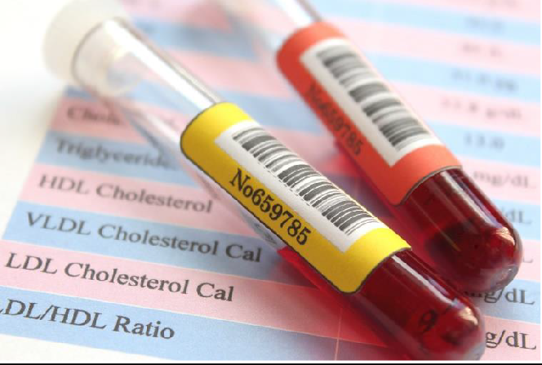

IT IS THE PATIENT’S RESPONSIBILITY TO FOLLOW-UP THEIR RESULTS.
Test results are reviewed by your doctor
Unless you have opted off or have not provided a mobile number the Hotdoc SMS Recall system will send you an SMS with a message from your doctor about your results or an email if you do not respond to sms . It will send you a link. This is safe to click on. Follow the SMS instructions. If asked, you must return and see the doctor. There will be important follow up needed.
If it is impossible for you to return you have the option of a telehealth appt.
For confidentiality reasons and as they are not doctors receptionists cannot give any results to patients at the front desk or over the phone. If you have tests done ask the Dr when and how to receive your results at the consultation.
If requesting copies old blood results contact Sullivan Nicolaides directly on patientservices@snp.com.au
If you need results for a specialist visit ask their receptionist to request them from the lab or xray place itself

CANCELLATIONS
It is very important that you phone us well before your appointment if you are unable to keep it. We always have more patients than appointments, so your failure to make that appointment available for booking means another patient has been turned away when they were most in need of our help.
We have introduced a $40 potential cancellation fee for those who fail to notify us in advance (on more than one occasion) This is to signal to our patients that cancellation of appointments is important in this practice. Bulkbill patients will not be bulkbilled in future if they fail to cancel on more than one occasion or be permitted to book on line.

WHAT TO DO IF WE ARE FULLY BOOKED AND YOU NEED TO BE SEEN?
If you give the receptionist an idea of what the problem is, they will try their best to fit you in or ask to speak to the nurse. Urgent appointments will always be seen if you indicate this when you call or a referral to an appropriate centre will be arranged.
Pandemic change in general practice role

General practice is no longer the frontline place to visit for colds and flus. The respiratory and Covid testing centres have been especially set up to protect general practice for the care of the general population during the pandemic. General practice must be preserved and protected for this purpose. If colds and flus are accepted into the surgery we risk being shut down and not be able to provide medical care to 1000s of patients so for the community good this is necessary

WE HAVE A NO SMOKING POLICY

Qld cervical screening and Bowel screening registers now keep your records on the National Cancer Screening Register and will remind you when youre due

INFECTIOUS DISEASES
YOU MUST NOT COME TO THE PRACTICE WITH COLD OR FLU OR “HAYFEVER” or SINUS SYMPTOMS
(which mimic cold symptoms). Or other infectious diseases.
Book a telehealth appt to discuss and assess next step.

Things that you can do to prevent spreading the flu and COVID are to:
- When calling, Inform receptionist if you have travelled overseas or have been exposed to a family member or friend that returned from overseas and may suspect that they have the cold or flu or Covid, or are awaiting Covid testing results or been to hotspot.
- Cover your mouth and nose when you cough or sneeze with your elbow
- Clean your hands with soap and warm water for 20 seconds or wipe your hands with alcohol wipes or antiseptic gel regularly
- WEAR a mask , KEEP 2 M AWAY FROM PEOPLE
- Stay home from work if you have symptoms, get tested and Self isolate
- DO NOT COME INTO THE PRACTICE WITH COLD FLU OR HAYFEVER OR SINUS SYMPTOMS- BOOK A TELEHEALTH APPT ONLINE FIRST TO ASSESS SITUATION FIRST

TRANSFER OF RECORDS
The introduction of the new privacy legislation has resulted in an increase in the costs of providing records and summaries. Where this task could be done by a receptionist before, the increase in complexity the legislation brings means now a doctor must do them. The privacy legislation allows for an administration fee
to be charged in recognition of this increased complexity.
We are happy to transfer care over to your new doctor and send a summary and there is a fee of $40 (plus $15 registered post fee to ensure your privacy and your records are delivered to you or your nominated doctor if that method of delivery is requested) or $100 for full records. Or electronic transmission is also possible and we don’t charge the postage fee then) . However, if you see/ book telehealth your Dr and book a standard appointment, we will bulkbill that and give you copies of needed items to take with you (book a transfer of records appointment).
A signed release form and photo identification with your signature should accompany any request for transfer from the patient to their continuing care doctor. (Transfer request Form available on our website or at your new doctor).
Requests will take a maximum 1 month to process. Patients who choose to pick up a copy of their medical records or sent to them personally must show proof of their identity and it must be the person requesting the records who picks them up. Doctors prefer to have a bulkbilled telehealth appointment to interpret their findings to you as they will not have the reassurance another Doctor will view them soon and so need to be sure you know all appropriate follow up care that is needed is flagged. If they are sure they have the correct person, they can send them via email.

HOME VISITS
Home Visits are available to our regular patients who live in the CBD and who are genuinely too sick to attend the surgery (they are provided during pre- arranged times by mutual agreement).
Requests are best made before 10am. Home visits are not bulkbilled. They are billed at AMA rates - ask reception for costs. Or if preferred a medical transport car or ambulance transport can be arranged to bring you in to be seen at next available appointment. This way we can see you faster at lesser cost.

AFTER HOURS
We have an after-hours number available to our regular patients to contact one of our GP's after hours. The number is listed on our business card and after- hours telephone message. Our after-hours service is not available to non-patients of the practice or patients not seen at least twice in last 2 yrs.
In emergency:
Wesley Emergency Centre

Ph: 3232 7333
St Andrews Priority Emergency Centre Ph: 3834 4455
Greenslopes Private Emergency Centre Ph: 3394 7111
Mater Private Emergency Centre Ph: 3840 1000

The Public Hospital Emergency Centres - Mater at South Brisbane, Royal Brisbane at Herston and Prince Charles Hospital at Chermside, Logan Hospital at Logan are all open 24 hours a day. They are free but waiting times are 2-3+ hours.

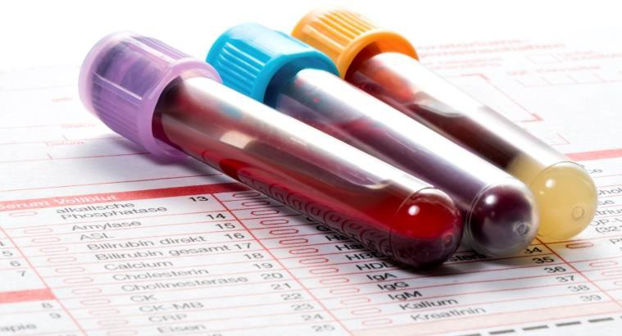

ONSITE PATHOLOGY SERVICES
Sullivan Nicolaides Pathology (on ground floor) Ph: 3210 2180
RADIOLOGY
Citiscan Radiology and Ultrasound, 141 Queen St Ph:3035 3700

SERVICES AVAILABLE AT BRISBANE CITY DOCTORS
- All general medical, family and children’s care.
- Women’s Health, Cervical Screening test, breast checks, contraception, sexually transmissible disease checks, pregnancy testing, pregnancy care, implanon insertion and removal, removal of IUD.
- Osteoporosis checks. Hormone replacement and other menopause therapy.
- Psychological support and mental health plans
- Men’s health, prostate checks, impotence problems.
- Heart Health Checks from age 40 annually.
- Travel vaccinations – we are online to Travax the international travel advisers. A printed travel advice report is given to every patient.
- Children’s growth and development check vaccinations.
- Minor surgical procedures (mole excisions, skin cancer treatments, toenail removal, suturing and wart treatments)
- Musculoskeletal medicine - Trigger point therapy for fibromyalgia, chronic pain states, sports injuries. with Photo modulation laser, Medicals for employment, immigration, insurance.
- Diving medicals (Dr Huynh)
- Executive medicals. Preventive health checks.
- Heart Health checks (bulkbilled for the over 40’s and earn under $40,000).
- Cancer screening if symptoms.
- Skin cancer checks using handheld microscopes and molescanning machines.
- Lung function testing.
- Hearing tests.
- Skin checks ,Mole Scanning Appointments (computerised).
- Workers compensation and workplace visits.
- Smoking cessation.
- Treatment for musculoskeletal injuries and all painful states.
- Occupational Medicine – workplace vaccinations (non-Medicare rebated), medicals, ergonomics checks, pre employment checks, hearing tests, return to work programs. Drug and alcohol testing.
- Weight Management
- Erectile dysfunction treatments
- Cosmetic clinic
- Ear suction for wax and infection
- STAYING ALIVE program for the over 40’s. This is not a medical examination (but can be combined with a full medical) but a review of all family history. We look at risk factors in lifestyle and occupational history and preventive genetic testing is available if you want to check for increased tendencies to cardiovascular diseases and cancers. Additional full body screening for cancers and diseases using latest technology to detect any cancers very early so they are treatable/curable. $295 for appointment to develop a personalised screening program. Investigations are extra
- Genetics Testing for prenatal pregnancy planning for couples to exclude hidden genetic disease in their offspring. Some diseases will only show when the couples genes mix and may not be in either’s family history

- Genetics testing for Propensity to various diseases
- Microbiome testing for checking if you have healthy gut bacteria and special diets advised to get the Microbiome back in balance. Disordered gut biome is thought to be responsible for increased heart disease, depression and anxiety, Rheumatoid arthritis, obesity and many more
- Heart Health Checks - Medicare will now allow everyone to have one of these every year from age 45 (earlier if early family history)
- Photomodulation laser treatment for musculoskeletal injuries and chronic pain. The latest in this technology where the body’s immune systems are triggered to heal themselves. Appointments after the first one are bulkbilled.

PATIENT RIGHTS
In our practice, we do not refuse access to care on the basis of gender, race, disability, Aboriginality, age, religion, ethnicity, sexual preference or medical condition.
We encourage patients to self-identify cultural background (e.g. Aboriginal and Torres Strait Islander self identification) on their ‘new patient registration form’ and this information is recorded in their health record.
Patients are encouraged to provide their next of kin AND an emergency contact at the time of booking an appointment and update any changes.
Our practice provides a health service that accommodates a diverse multicultural population including those with disability.
Patients who do not speak English or who are more proficient in another language, have the ability to choose a professional translating service or a translator who may be a family member or friend. Children should not be encouraged to translate on their parent’s behalf. In some situations, it may also not be appropriate for a family member or friend to translate.
Our practice encourages patients to utilise the free Translating and Interpreting Service (TIS). The TIS is a free service available 24 hours a day via telephone at the time of consultation or onsite at the practice if 48 hours notice is given. Further information about the TIS is available on the TIS website.
A free interpreting service is available for patients who are deaf and use Australian Sign Language (AUSLAN). Contact the National AUSLAN Interpreter Booking and Payment Service (NABS) on 1800 246 945 or visit the NABS website for further information.
- Make a longer appointment to accommodate interpreting time (min 20 mins).
- These appointments are NOT BULKBILLED due to their time and complexity.

PRIVACY
For further information, on how we manage your health information please see our privacy policy by scanning the QR code below

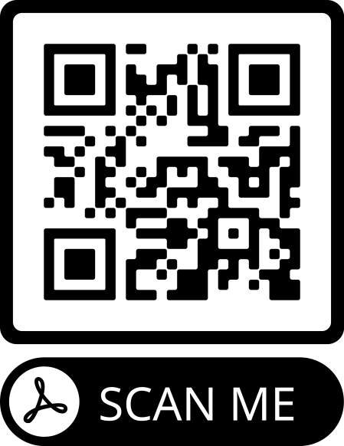

RECALL AND REMINDER SYSTEM
There are many reasons why our practice coordinates a structured recall (for important follow up) and reminder system (for routine follow up). In the first instance, it provides patients with the safety and comfort of knowing that their doctor is monitoring their health from a distance by issuing messages and reminders for follow up or preventive care and recalling them to discuss results of test requests and referrals. All doctors use these in different ways so do not assume you will be sent a reminder. Have your own system in place e.g.: diary to remind you of when your visits and follow up are due.
There is a duty to have a recall system for abnormal results. Drs will contact you re urgent results. For non urgent abnormal result appts, you will normally receive a Hotdoc SMS message after your doctor has reviewed your results. It has a link. It is safe to click this link for a message from your doctor re your results. Only 2-3 sms will be sent and an email if you do not respond. Then our attempts to contact you will cease. However, it’s your duty and responsibility to keep your contact details and emergency contacts up to date with us at all times. If not ,you will not receive important messages from us. Please advise reception if we cannot contact you via SMS/email. If so you will need to make a follow up appt after any test is ordered. We prefer you not to use your work email for contact which is owned by your employer.
We also use the Hotdoc app to send SMS/email to contact you re messages from the doctors for you, for results recalls, appt reminders, reminders re care due, SMS/emails for sending health information and advising re services available. If you don’t wish to receive these notify the receptionists but they are very useful services and Drs like to use them for patient care. Please visit the Hotdoc site for their privacy and security policy. Our general email is not encrypted so confidentiality cannot be assured. Do not use if you don’t accept this situation.

VACCINES
- Cholera (Dukoral)
- Diphtheria/tetanus/whooping cough
- Diphtheria/tetanus/whooping cough +/-polio
- Diphtheria/tetanus
- Hepatitis A
- Hepatitis B
- Hepatitis A & B combined (Twinrix)
- Yellow fever (Stamaril)
- Q-fever (skin test)
- MMR (Priorix) (measles, mumps, rubella)
- Japanese encephalitis (Imojev)
- Polio (poliomyelitis) (Ipol)
- Rabies (Merieux/Rabipur)
- Typhoid (Typhim IV/Typherix)
- Typhoid & hepatitis A combined (Vivaxim)
- Varicella (Varilrix / Varivax)
- HPV – Gardasil 9 (up to 45 years)
- Meningococcal (Acwy/Menactra/Menveo)
- Pneumococcal (Pneumovax) (OVER 70)
- Zostavax (Shingles)
- COVID VACCINES
COVID VACCINES
We have both Pfizer and Astra Zeneca vaccines. Please book appts on line. Pfizer is booked through the Automed portal. Book your second appt at the same time.
You will need to wait a min of 15 mins afterwards to be observed.

WHY DO DOCTORS RUN LATE?
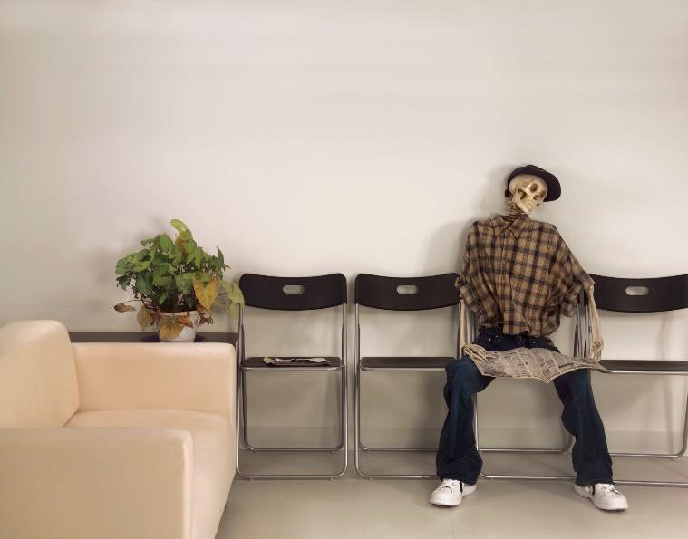

Doctors run late because Patients:
- Arrive late for appointments
- Don’t book enough time for the problem they have come with
- Have medical emergencies
- Consultations are interrupted by phone calls
- Epidemics occur

As you can see, the doctors aren’t in control of any of these factors. We can't control for epidemics and emergencies but your assistance with the other factors will help us to run on time.

WHAT YOU CAN DO TO MINIMISE WAITING TIMES?
- The most important thing you can do is book enough time for your health problem. This is the prime reason Drs run late and late arrival for appts. If you don’t need a longer appt and you have booked it DRs will adjust billing. Reception s
- Arrive on time, with time for processing at front desk. If you are late and someone else is early, they will go in before you and delay your appt. Let receptionist know if you are here for breathing test, ECG, pregnancy test so tests can get underway while awaiting your appointment with the doctor
- If returning for an X-ray result or Travel Advice reply, ask for it at front desk and bring it travel report with you to the consultation
- Ring well in advance if you can’t make your appointment. This allows us to allot an urgent appt to a true space and not have to fit it in where there is no space and thus delay appts after it. It also helps to maintain bulkbilling as long as possible since every unfilled appt causes a loss to the practice. It also saves you being charged the non- cancellation fee!
- Book ahead, don’t -leave it till the last minute.
- Book a minimum 20 mins for a life crisis situation or a complex problem or women’s health problem involving bleeding or a pain without an obvious diagnosis, and tiredness
- Be realistic in your expectations and aware a delay is possible when we are dealing with people’s lives. Factor this into your expected time out of work. (It is unrealistic to expect to be seen in a 15-min coffee break or just before your bus leaves- this is a recipe for disappointment!)
- Book first appointment after lunch or in the morning as these have the least potential to be delayed by emergencies
- If you phone for an estimate wait time, it will be rough only as waiting times vary minute by minute.
- Come on rainy days and Wednesdays – they are always quieter.
- Avoid short weeks, and the day after a public holiday – they are always very busy.

STAYING ALIVE PROGRAM
Predicting your health future
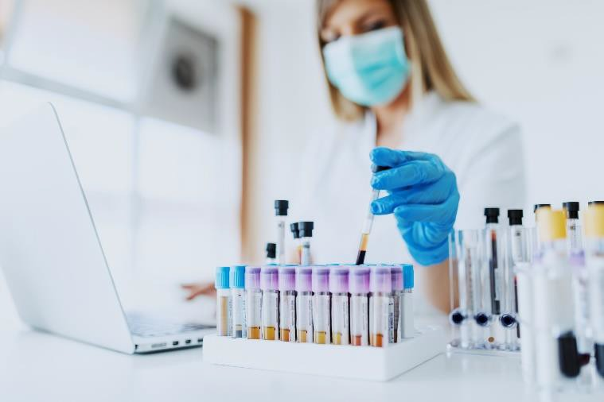

Family history is the best predictor of your future health risk issues. You share 50% of each of your parent’s genes and 25 % of your grandparents.

Diseases in your family tree take account not only of genes but environmental influences as well.
Genetic testing for susceptibility to various diseases is available. The current one we use is for cardiovascular disease risks (heart attacks and strokes) and cancer risks. This testing advises if there are increased risks due to faulty genes. Remember having some dodgy genes is normal- the important thing is to take action to mitigate your long-term risks. Biology is not destiny!
Knowing we have a variant that has an association with a disease, can be a powerful motivating factor to change. In others this information will be ignored.
We do recognise this is very much a new frontier and a “watch this space”
However when gene testing is combined with thorough family history, assessment of current risk factors , realistic appraisal of the genetic information’s contribution to risk and health education, we can sharply focus our patients attention on their relevant health risks and hopefully motivate change.

WE ARRANGE TOP TO TOE SCREENING FOR CANCERS AND DISEASES TO DETECT THEM AT AN EARLY AND CURABLE STAGE.
Make an appointment today for your Staying Alive Program and take control of your future. Phone 3211 1024 and speak to the Manager.

ATTENTION: ALL COUPLES PLANNING A PREGNANCY
TESTING FOR RECESSIVE DISEASES
Genetic testing for 100 potential recessive diseases prior to a pregnancy is now possible e.g.: cystic fibrosis. Recessive diseases usually show no prior family history and appear "out of the blue" because the two parents each carry a gene that requires 2 genes to be present to express disease and one each can be passed on from each parent who don't have the disease themselves or in their family tree.
The chance that you and your partner are carriers of the same disease is low. In fact, less than 1% of couples
who take the Test will turn out to be carriers of the same disease. If you fall into this category, your chances of having a child with symptoms of the disease are 1 out of 4. That's a 25% risk with every pregnancy you embark upon together. Based on your personal values, you may consider one of the following family planning options:
Prepare for birth, Prenatal diagnosis, Fertility treatment, Change of plans.
Both partners need to be tested.

ALL MEDICALS AND PHYSICALS
LOWER GROUND Floor Manor Apartments
PH 322111024
WE OFFER A FULL RANGE OF HEALTH SERVICES TO COMPANIES AND INDIVIDUALS

▪
▪
▪
▪
▪
▪
▪
▪
▪
▪
▪
Pre-Employment Medicals
Diving Medicals
Commercial Drivers Medicals Dangerous Goods Medicals Transport Workers Medicals Executive Medicals
PNG medicals

Rail cat 1,2,3 medicals
Coal Board Medicals
On site or at Workplace Vaccinations
Nurse Health Screening Checks at the Workplace
Personalized
vaccinations
Travel
advice
information
and
- Pathology Blood Collection On Site
- Drug and Alcohol Testing – Instant and Laboratory
- On Site ECG , Blood Pressure and Holter monitoring
- On Site respiratory function testing
- On Site hearing & vision tests
- Full General Practice Services offered at the associated Brisbane City Doctors located on Lower Ground Floor

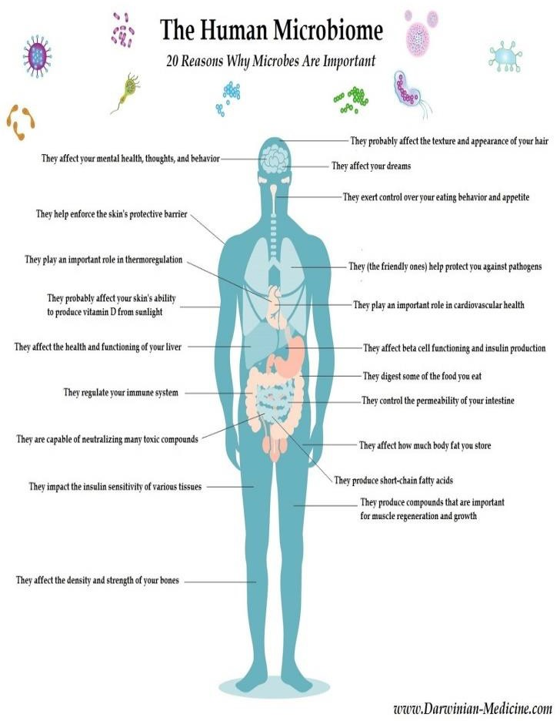
OVERSEAS AID WORK
Our practice supports cervical cancer screening in Vanuatu via our involvement in Australian Cervical Cancer Foundation. The Drs do Aid work over there
www.accf.org.au
Please visit the website to make a tax deductible donation for Vanuatu. Please consider a bequest. Every $100 donation vaccinates 5 girls against cervical cancer. Every $100 screens 10 ladies for cervical cancer. Be sure you go to the everyday hero page to donate as the overseas page goes to other countries. Call ACCF to say the donation is for Vanuatu
Proceeds from sales of Entertainment Books also go to the Australian Cervical Cancer Foundation.

MICROBIOME TESTING
This is a new area of medicine that links the gut bacteria to many diseases including obesity, rheumatoid arthritis, neurological diseases like Alzheimers and Parkinson’s, irritable bowel, Crohns disease, anxiety and depression.
Having health bacteria can reduce these diseases. So, the testing advises you if your biome is a healthy one and if not what to do to get it back to a healthier position . Dr McAdam has an interest in this. The test costs about $350 plus Drs visit $149 (rebate approx.
$79)

