[ResHealth](https://help.kinnect.com.au/en/collections/3801242-reshealth)

How to Initiate a Health Assessment in ResHealth for Coal Board Medicals

From 1st April, all Queensland Coal Mine Workers Health Assessments must be initiated in the new online platform, [**ResHealth**](https://www.rshq.qld.gov.au/reshealth).

**Key Points:**

* All Health Assessments MUST be initiated in ResHealth
* Employers will need to provide key information (HA Number + AMA)
* We need Lungscreen number (candidate must register on Lungscreen.com and use the exact name and DOB you give us when you book in) + advise if the Lungscreen Xray is urgent (few days for a result) or non urgent (2 weeks)
* It's essential that candidates/workers complete their section 2 in ResHealth before an appointment can be scheduled
* We will not proceed with scheduling any appointments until the worker has confirmed they have completed their section 2

**The New Process**

**1. Initiate the Health Assessment (HA) in ResHealth.** You have the option to either initiate a HA for an existing worker (who is already in ResHealth), or initiate a HA for a new worker. During this process, you'll be asked to nominate the AMA. Take a note of these details as you'll need this information and the HA Number that is generated for the next step. Note there are support guides for using ResHealth on their website if you need assistance in initiating the HA: [**https://www.rshq.qld.gov.au/reshealth/support-guides**](https://www.rshq.qld.gov.au/reshealth/support-guides)

[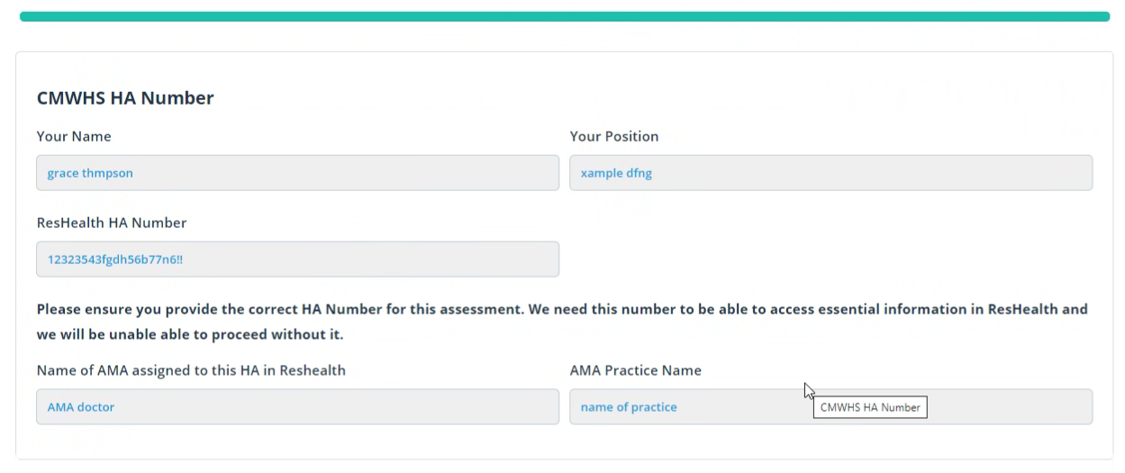](https://downloads.intercomcdn.com/i/o/686343236/91d7f7678c350e91b23c6b07/image.png)

**2. Candidate completes their section 2.** As soon as you've initiated the HA request in ResHealth, this will trigger an email requesting they complete their Section of the HA (previously called Section 2).

**3. Once section 2 done by candidate, Make an appointment with us for their medical. We need Name, Dob, contact ph and email, Lungscreen number and urgency of the lungscreen Xray and the Ha number for the booking** and company contacts for accounts paying. This appointment includes the Health Assessment that will be completed by the EMO, and the Chest X-Ray (ILO) and the spirometry (breathing test) . If a drug and alcohol test is also required this is an extra test as not a usual component with a coal board medical but the employer may want it. We will send a confirmation with appt times.

**4. Request for previous medical records.** If the candidate has indicated they have previously worked in the Coal Industry, they need to request their previous medical records for review. A request will need to be made to HSU to obtain the records. Please note, this process could take up to 5 business days.

**5. Assessment conducted by EMO.** The HA will be conducted by the Examining Medical Officer (Drs Pav Chopra or Dr Tia Singh or Dr Fernandez) and the results will be recorded directly into ResHealth.

**6. AMA reviews results. The AMA is an independent off site Dr who signs off on the medical.** The AMA will review the medical information provided by the EMO and compiles the HA Report in ResHealth.

**7.. HA Report complete.** As soon as the AMA has compiled their report, the HA will be ready to view and download in ResHealth. The candidate and employer will receive a notification directly from ResHealth when the HA Report is completed.

**8. Results.** Where the candidate has completed a functional assessment or other testing as part of their assessment, the Company Medical / Functional Results will be sent separately